Isabella Monzon

Lindska Flores

CGS1060C

14 March 2023

Sports Reference Excel Analysis

The Los Angeles Lakers are an NBA basketball team known for its talented players. Data has been collected from the 2022-2023 season and analyzed on their completed games so far. As of the last game against the New York Knicks, it has been recorded that out of the 69 total games completed, the Lakers have a total of 7765 points which averages about 113 points per game. Thanks to filtering through excel, we can analyze the total amount of points explicitly accumulated through games that have been won. This total comes out to 4226 points in games won which averages to about 114 points during won games. More than half of the points the Lakers made are attributed to games that they have won.



Pivot tables allow you to take an inside look at data and create several discoveries. Specifically for the L.A. Lakers, the games won and lost against 7 specific teams: Atlanta Hawks, Boston Celtics, Chicago Bulls, Detroit Pistons, Golden State Warriors, Miami Heat, and the New York Knicks. The Lakers had 626 points combined within the games they lost and 953 points total in the games they won. When you transform this data to be read as a percentage of the total, the loss points account for 42.86% of the total, and the win points account for 57.14% of the total. This data shows us that when the Lakers are ahead overall throughout the game, they have a higher scoring percentage and it should usually end in a win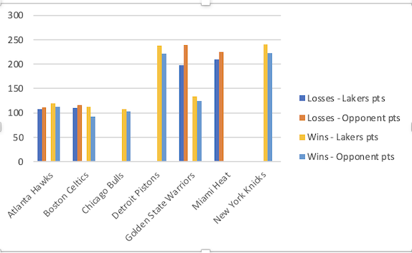

The Miami Heat are an American professional basketball team based in Miami. The Heat compete in the National Basketball Association (NBA) and have won three NBA championships. The 2022–2023 season's data has been analyzed in terms of their completed games so far. Records show that out of 72 total games completed, Miami Heat have a total of 7847 points, which averages about 108 points per game. Fortunately, with the help of Microsoft Excel, we can easily sort, filter, and analyze NBA data. We can look at the total number of points that have been earned and games that have been won. The total points won comes out to 1355 with an approximate average of 18 points. As a result Miami Heat now have a record of 38-34.

